**LAB 2: RedSo Blockchain Demo**

**Overview**

The purpose of this lab is to use a demo Decentralized App (DApps) called RedSo on trading watches where all transactions are made in Ethereum network.

**Prerequisites**

You should have completed Lab 1 – Metamask Setup, created an account in Metamask wallet and have some ether in Rinkeby Test Network.

**RedSo (<https://redso-blockchain-demo.redso.com.hk/> )**

This is a demo Decentralized App (DApps) on watches trading. You can buy watches or post watches to sell on the website. The transactions are all made in Ether. All the trading records of a particular watch are listed on the Ethereum network so you can know how many previous owners there are and what are the previous prices. By the transparent nature of blockchain, everybody can trust the watch actually comes from a legitimate source by tracing the source of origin.

1. **Set your network to the Rinkeby Test Network**

This demo website is running on the Rinkeby Test Network, please set your wallet to the Rinkeby Test Network.

Click the Metamask small fox icon on your browser. Once you Click the dropdown menu on the top of the metamask window. You will see list of networks. Select Rinkeby Test Network as your network like below:

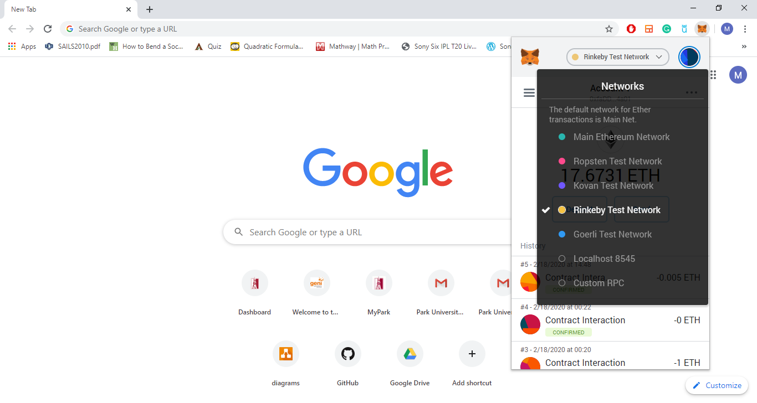

1. **Buying a Watch**

Once you are in the demo website, you can see a list of watches (1 entry is 1 particular watch). There should be some watches showing with the “Buy” button. Click on the button, and your wallet will prompt you with a notification window.

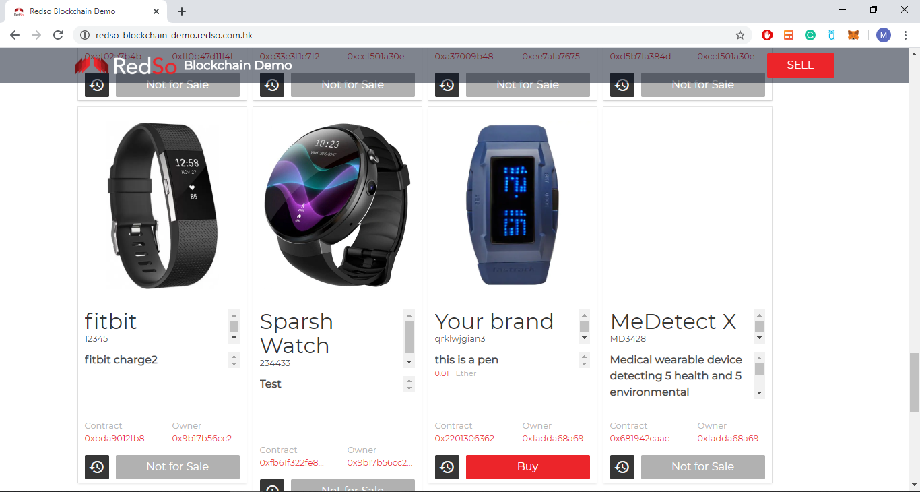

Click on the “Buy” button, and your wallet will prompt you with a notification window.

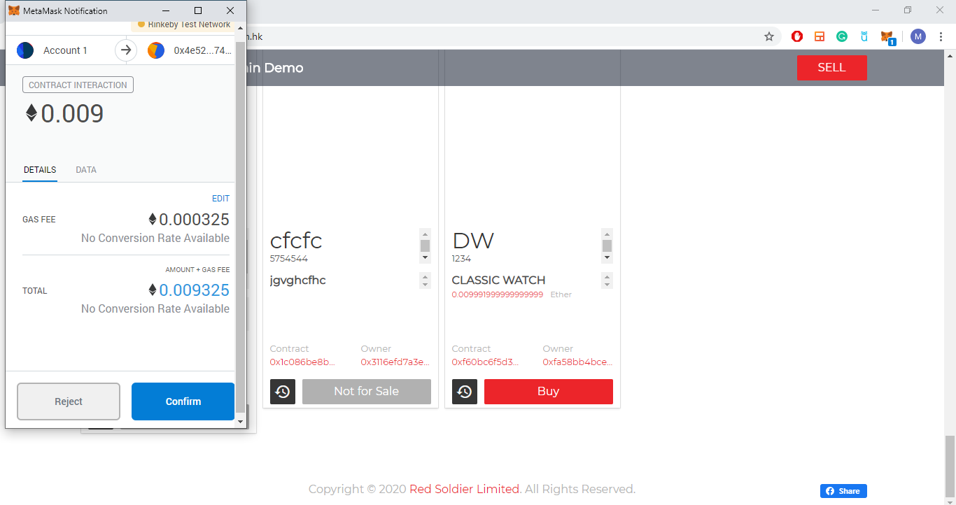

Once you click “Confirm” button. Now, if you go back to the Metamask window on the browser you will see the new confirmed transaction. Click the transaction. You will see the transaction details on the metamask like below. To view the transaction on the Etherscan you can click the button on the right side of details Tab.

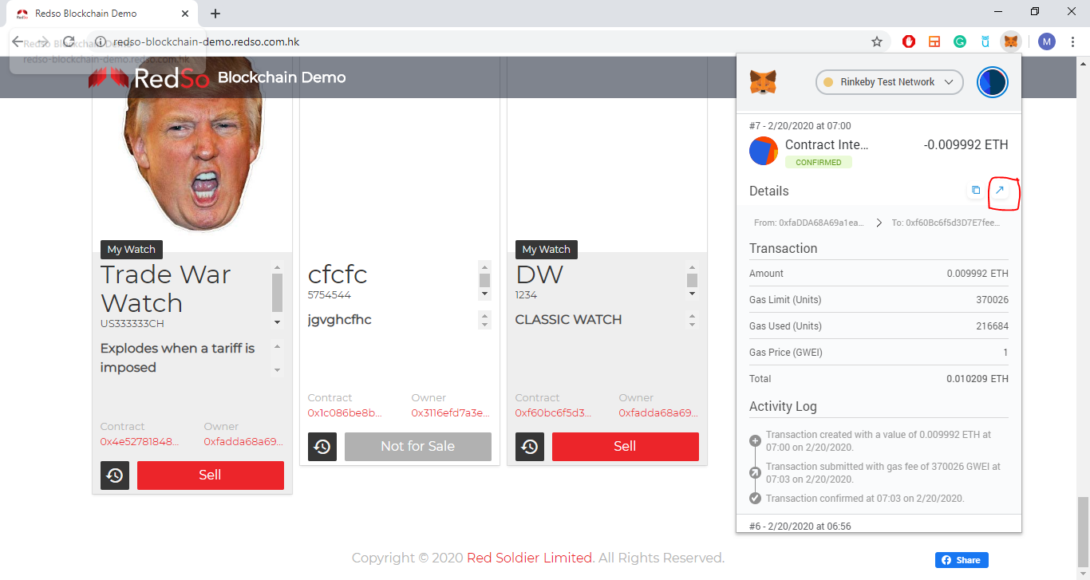

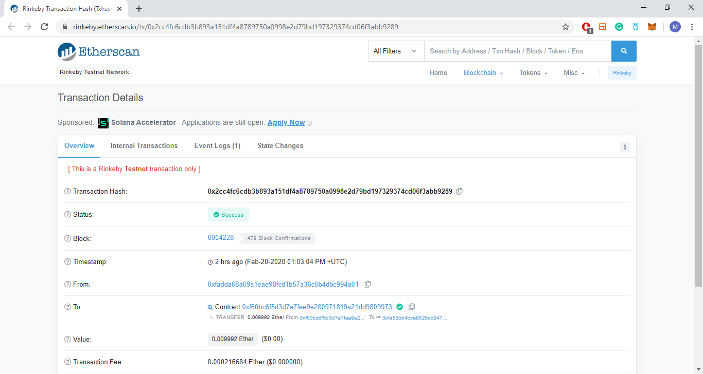

1. **Selling a Watch**

Once you have bought a watch, it will show your watch as My Watch on demo site like below:

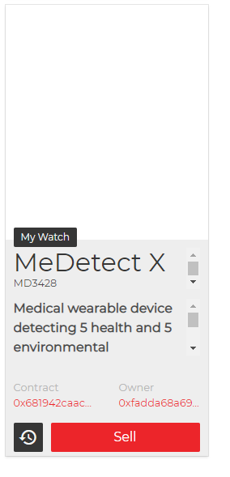

Click Sell button and a window will appear. You have to enter Selling Price in Ether.

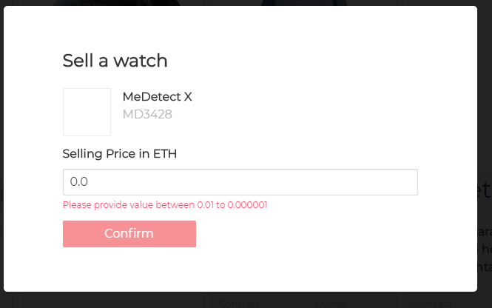

Once Click Confirm, you will see a metamask window telling you about paying the gas fee for the transaction to sell your watch.

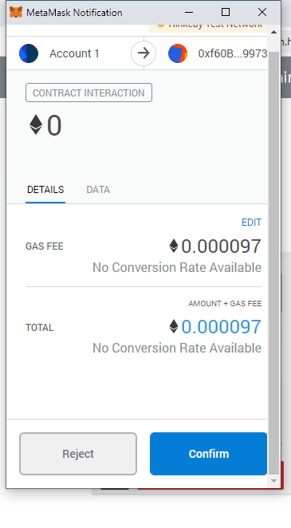

Click Confirm and once your transaction is confirmed your watch window will appear like below:

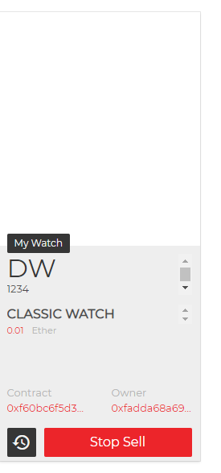

Once someone on the network buy your watch the selling price of your watch will be deposited to your account.

**Setting up gas fee:**

The gas price is the unit price of gas you are paying in order to write your transaction record to the blockchain.

If you click the edit on the window during confirmation of your transaction like below:



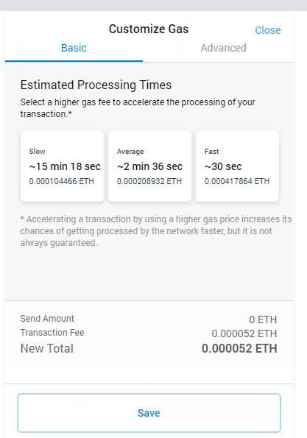

This will give you the idea about how much gas fee you pay depends on how fast your transaction will be confirmed and applied to the network.